5. Write a C program to find Factorial of a given number using Recursion

**Aim:** To write a C program to calculate the factorial of a given number using recursion.

**Algorithm**

1. Start the program.
2. Define a recursive function factorial(n):
   * If n == 0 or n == 1, return 1.
   * Otherwise, return n * factorial(n - 1).
3. In the main function:
   * Read a number n from the user.
   * If n is negative, print that factorial is not defined.
   * Otherwise, call the recursive function factorial(n).
4. Print the factorial result.
5. Stop the program.

**Program**

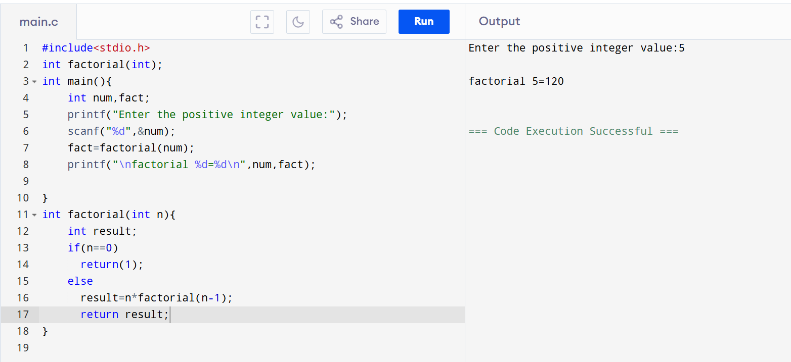

**Result:** Thus, the C program to calculate the factorial of a number using recursion was successfully executed.